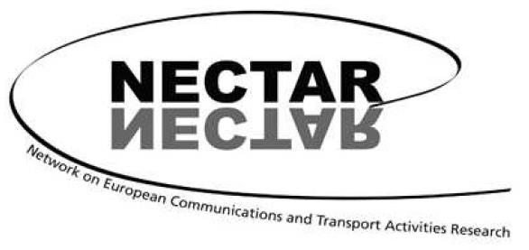

17th International NECTAR Conference
Brussels, Belgium, 3 - 5 July 2024

Stakeholder involvement in transport: Who, why, how and with what impact?

General Call for Papers

The involvement of stakeholders is key in the planning and regulation of transport systems, services and infrastructure, the design and deployment of innovations and in the evaluation of transport activities. However, the diversity of stakeholders, their roles and responsibilities and their degree of willingness to participate in research and planning vary greatly across the different transport domains and at different stages of transport planning. Therefore, new methods, approaches, tools, and insights are needed to better understand why stakeholder involvement is important, who are the key actors that should participate, how they can be involved, and what impacts transport has on them. Stakeholder involvement is not only relevant for transport infrastructure projects, but also for supporting the long-term transition of transport towards a low-carbon and sustainable future.
The focus of the conference is on how transport and communications research can support the different roles stakeholders take in transport planning. Stakeholder involvement is understood in the broader sense. We invite papers discussing the following specific topics of interest:
- advancements in the fields of transport and communication in the context of stakeholder involvement,
- development of regulatory approaches and policies,
- stakeholder-based decision support,
- citizen engagement,
- quantitative and qualitative methods to assess the impact of transport on different stakeholder groups.

In addition to these topics, we welcome papers on topics in the fields of transport, communications, and mobility at large. General topics of interest include transport and infrastructure evaluation, transport policy and environment, logistics and freight, tourism, recreation and leisure, housing and labour markets, accessibility analysis, social and health issues, and ICT.

The different NECTAR clusters will also organize specific thematic sessions. Calls for papers for these sessions will be posted on the conference website and the NECTAR website.

The deadline for abstract submission has been extended to February 15, 2024. Abstracts should be submitted electronically, using the form available on the conference website and following the instructions found there:

https://mobilise.research.vub.be/nectar-conference-2024-general-call-for-papers

Criteria for acceptance
Criteria for acceptance are scope, scientific quality, NECTAR membership and the possibility to fit the presentation in a coherent conference session. We allow one paper presentation per participant.

Venue
The NECTAR conference will be organized by the Vrije Universiteit Brussel and hosted on its campus.

Participation and NECTAR membership
Registration, meals, and accommodation for one night will be offered to NECTAR members, for only one author per paper. One night of hotel accommodation will be offered to participants who have confirmed their participation before April 30, 2024. One night of hotel accommodation might be charged in case of late cancellations. All practical details will be communicated through the conference website. In order to participate in the conference, a consecutive and current two-year NECTAR membership is necessary (2023-2024). Non-members can find details of how to join the association on the “Membership” page of NECTAR’s website: www.nectar-eu.eu/membership.

Important dates:
Abstract submission: Jan 31, 2024
Notification of acceptance: March 15, 2024
Confirmation of attendance: April 30, 2024

We look forward to seeing you in Brussels!

Cathy Macharis, Vrije Universiteit Brussel
Imre Keserü, Vrije Universiteit Brussel
Karst Geurs, NECTAR chair

NECTAR is a European-based scientific association. The primary objective is to foster research collaboration and exchange of information between experts in the field of transport, communication and mobility from all European countries and the rest of the world. It is a multidisciplinary social science network bringing together a wide variety of perspectives on transport and communication problems and their impacts on society from an international perspective. For further information on NECTAR, use the link: http://www.nectar-eu.eu.

